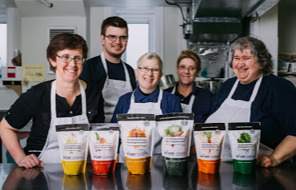

Grace Missions presents:
“ The Raw Carrot Soup Enterprise”.

We partner with churches to create jobs for amazing, talented individuals, living with disabilities and mental health issues.

Buy Soup. Create Jobs. Simple.

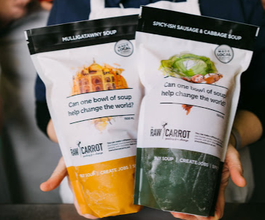

Order ? See next page ….

Please submit your Soup order on the attached Form and hand over to Mike or Mike.

Email? Send your Soup order to mikejpm54@gmail.com

Phone? Call evenings, either Mike Maingot at 647-878-3614 or Mike Morris at 905-903-4856.
Each soup is a 750 ml pouch (3-servings), comes frozen. (For more info on the soups, visit our website https://therawcarrot.com/raw-carrot-soup-enterprise-soups/
- Price: $10 each (750ml, 3-serving pouch) You will pay us (Mike & Mike) and then we will pay and order the full amount, pick up and store in freezer at Grace, until we can hand-deliver to you.
Here is the list of the handcrafted, gourmet soups that are available.
CHOICES: | Quantity
A-Signature Carrot Soup (*Vegetarian/Vegan/Gluten-Friendly)
B-Flying Noodle (Gourmet Chicken Noodle) Soup (*Bone Broth)
C-Hearty Lentil and Barley Soup (*Vegetarian/Vegan)
D-Loaded Potato and Bacon Soup
E-Spicy Sausage and Cabbage Soup (*Gluten-friendly)
F-Mulligatawny- curried, vegetable, coconut milk.

NAME___________________________________________________

PHONE_____________________________________

