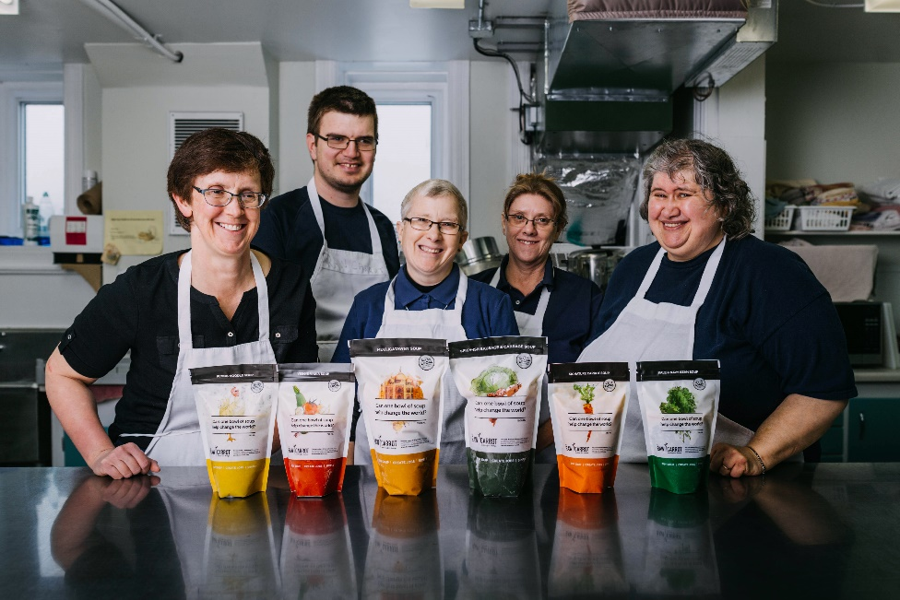

The Raw Carrot - Employment with Purpose
The Raw Carrot is a social enterprise that empowers people who face barriers to traditional employment to secure their own livelihoods through the dignity of work.

100% of every purchase of gourmet, handcrafted soup creates meaningful employment, relief from poverty and dignity for amazingly talented individuals on social assistance.

Your purchase is “stirring up” change in local communities!

Buy Soup. Create Jobs. Simple.

Raw Carrot Soup : A Hand Up rather than a Handout
Staff member Lori shares the impact of meaningful work on her life
(1-min watch) https://youtu.be/h9sqZHeZWtk

Watch the staff in action! https://youtu.be/szZ2Hg5nXIU

Find out more https://therawcarrot.com/

Information about our soups
https://therawcarrot.com/soups/



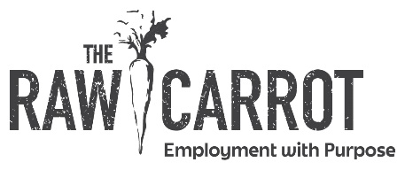
* Please pay cash to the Mikes, or e-transfer to mikejpm54@gmail.com. Email orders to mikejpm54@gmail.com. Please submit order by Tues Nov 25th.

All are 750 ml (2- serving pouch that comes frozen). |  | Quantity
 | (A) -Signature Carrot Soup $10 (vegan/gluten free)
 | (B) Flying Noodle Soup $10 (gourmet chicken noodle)
 | (C) Hearty Lentil and Barley Soup $10 (vegan)
 | (D) Loaded Potato and Bacon Soup $10 (creamy potato & bacon)
 | (E) Spicy-ish Sausage Italian Soup $10 (gluten free)
 | (F) Mulligatawny $10 (Spice flavours with chicken, vegetables and coconut milk, gluten free)
 | (G) Veggie Mania $10 (5 vegetable blend, gluten free)
 | (H) Butter Chicken Soup $12. Indian spices, creamy chicken. Only 20 available. Seasonal.
 | (I)Pancake & Waffle Mix $9 ( 400gms, serves 4-6 people)
 | (J) Granola Topper $6 Small jar 120g (no added preservatives and is naturally sweetened)
 | (K) Granola Topper $10 Large jar 250g (no added preservatives and is naturally sweetened)
 | Total Soups
 | Total Granola/ Mix
 | Total cost
More information about our soups on our website: https://therawcarrot.com/soups/

Name: ___________________________________________________

Phone: __________________________________________________

Email: ____________________________________________________ (We will add you to our monthly newsletter, you can unsubscribe at anytime)

